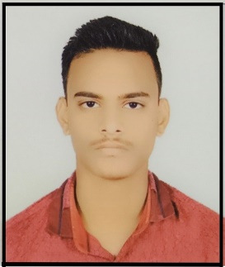RESUME

**SHUBHAM CHOUHAN**

12/3 Alakhnanda line 1st Battalion Indore

Email Id: Mr.shubham9040@gmail.com

+91-9009600415

**__________________________________________________________________________________**

**Career Objective**

To secure a challenging position in a reputable organization to expand my learning, knowledge and skills. Secure a responsible career opportunity to fully utilize my training skills, while making a significant contribution to the success of the company.

**Academic Record**

|  |  |  |  |  |
| --- | --- | --- | --- | --- |
| **Course** | **School/College** | **Board/University** | **Percentage/**  **CGPA** | **Year of Passing** |
| B. Sc (CS) | Govt. Holkar Science College ,Indore (M.P.) | Devi Ahilya VishvaVidyalaya, Indore (M.P.) |  | 2023 |
| 12th | Kendriya Vidhyalaya No.2, Indore | CBSE | 80.4% | 2020 |
| 10th | Kendriya Vidhyalaya No.1, Indore | CBSE | 71.4% | 2018 |

**Technical Skills**

|  |  |  |
| --- | --- | --- |
| **S. No** | **Operating System** | **Windows** |
| 1. | Languages | C, C++, JAVA (Core) |
| 2. | Database | MySQL |
| 3. | Microsoft Technology | VS Code |
| 4. | Tools | VS Code, NetBeans |
| 5. | Other Courses | Cyber Security |

**___________________________________________________________________________**

**Achievements & Activities**

* Certified by MSME-Technology Centre (INDO-GERMAN TOOL ROOM, INDORE) for **CYBER SECURITY & JAVA LANGUAGE**.
* Certified by Universal Informatics in **C , C++ LANGUAGE**.
* A Basketball player and recently represented my college in University Sports Meet which was conducted by DAVV university.

**Strengths**

* Self-confident, Focused, Quick learner, Punctual ,Teamwork.

**Weakness**

* Having trouble asking for help, emotional.

**Hobbies**

* Playing basketball, Running, reading books.

**Personal Details**

Father’s name : Mr. Mahesh Chouhan

Mother’s name : Mrs. Shushila Bai

Date of Birth : 14/03/2003

Gender : Male

Nationality : Indian

Marital Status : Unmarried

Permanent Address: 12/3 Alakhnanda Line, 1st Battalion, Indore (M.P.)

Languages Known: Hindi and English

**Declaration**

I hereby declare that the information furnished above is true to the best of my knowledge.

Place **:** Indore

***SHUBHAM CHOUHAN***